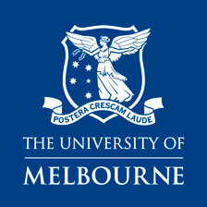
Completing a Concurrent Diploma alongside your Graduate program

SAMPLE ONLY: Master of International Relations & Diploma in Languages Course Map

Specialisation & Entry Point Level – French Studies (Entry Point 5)
Year | Study Period | 1 | 2 | 3 | 4 | 5
 | Semester 1 | MC-IR: HIST90024 | MC-IR: POLS90026 | MC-IR: Elective | MC-IR: Elective | No overload in first semester
 | Semester 2 | MC-IR: ASIA90008 | MC-IR: Elective | MC-IR: Elective | MC-IR: Elective
 | Summer/Winter | MC-IR: POLS90028
 | Semester 1 | MC-IR: Elective | MC-IR: Elective | MC-IR: Elective | D-LANG: FREN10006
 | Semester 2 | MC-IR: Elective | MC-IR: Elective | MC-IR: Elective | D-LANG: FREN10007
 | Summer/Winter
 | Semester 1 | MC-IR: Elective | D-LANG: FREN20019 | D-LANG: French Elective  (Level 2)
 | Semester 2 | D-LANG: French Elective  (Level 3) | D-LANG: French Elective  (Level 3) | D-LANG: French Elective  (Level 3) | D-LANG: FREN20004
 | Summer/Winter

MC-IR subjects | D-LANG subjects

